Scheduling algorithms

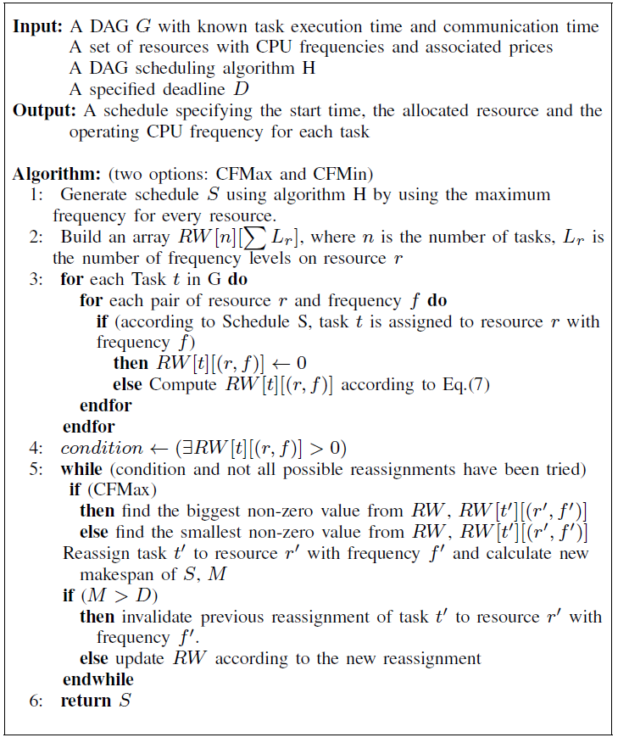

Out task is to change the scheduling algorithm for initial task H to MINMIN, MAXMIN, MCT and MET.

MINMIN

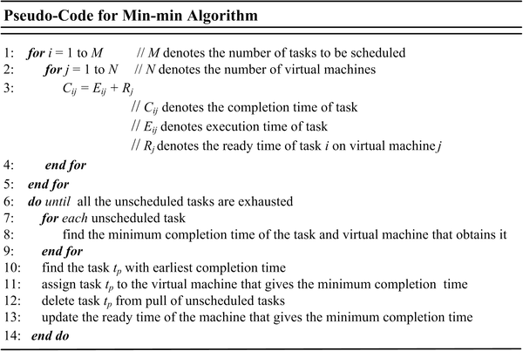

MAXMAX

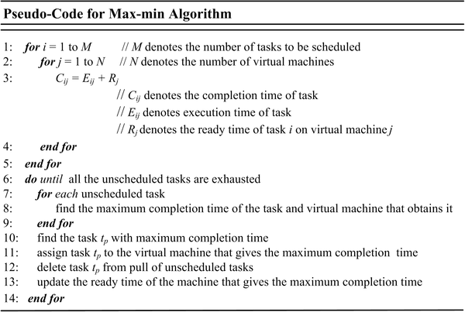

MET

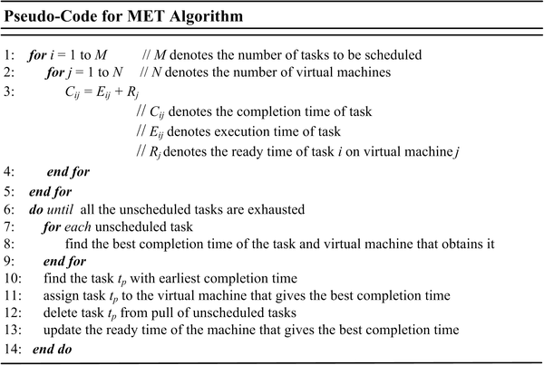

MCT

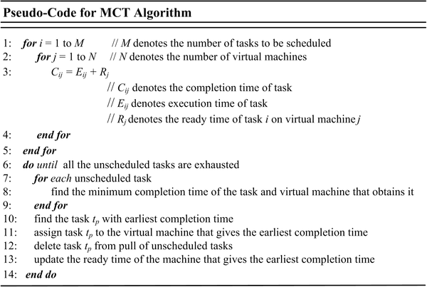

Evaluations

1. Robustness: Robustness probability $Rt$ and Tolerance time $Tt$

$$Rt=\frac{Total_{Run}-FailedRun}{TotalRun}$$

Rt is the likelihood of workflow to finish before the deadline where Total Run is equal to the number of times the frequency has been changed and Failed Run is equal to the number of time the changed frequency didn’t manage to meet the user deadline.

$$Tt=Deadline-Makespan$$

Tt is the amount of the time that a workflow can be delayed without violating the deadline

Those two metric will be inserted into CFMAX and CFMIN options

1. Cost, makespan, Degree of imbalance, throughput and Average turn around

Cost and makespan will be evaluated as in previous paper

Degree of imbalance (DI) describe the amount of load distribution amongst the VMs regarding to their competencies. $T_{max}$ signify the maximum load distribution, $T_{min}$ signify the minimum load distribution and $T_{avg}$ signify the average overall execution time of task among total VMs

$$DI=\frac{T_{max}-T_{min}}{T_{avg}}$$

Throughput uses the consideration of total number of tasks, which are implemented successfully in cloud computing, throughput means some tasks completed in a certain time period. Minimum throughput is required for task scheduling.

$$Throughput=\sum_{{task}_{i}}{({Exe}_{time})}$$

Where ${Exe}_{time}$ shows the execution time of $i^{th}$ task.

Turn-Around

$$AverageTA=\sum_{t_{0}}^{t_{i}}{(FinishTime-ArrivalTime})/NumberOfTasks$$

**Output**

Store Average turn around, DI and Throughput for each frequency tested and for each DAG

For other

For each **number of machine: 3, 5, 8**

For each **deadline metric: 1.5, 2.5, 5**

**HEFT** makespan: Total Cost

**CFMAX-HEFT** Makespan: TotalCost: Robustness: Tolerance:

**CFMIN-HEFT** Makespan: TotalCost: Robustness: Tolerance:

**MINMIN** makespan: Total Cost

**CFMAX-MINMIN** Makespan: TotalCost: Robustness: Tolerance:

**CFMIN-MINMIN** Makespan: TotalCost: Robustness: Tolerance:

**MAXMIN** makespan: Total Cost

**CFMAX-MAXMIN** Makespan: TotalCost: Robustness: Tolerance:

**CFMIN-MAXMIN** Makespan: TotalCost: Robustness: Tolerance:

**MET** makespan: Total Cost

**CFMAX-MET** Makespan: TotalCost: Robustness: Tolerance:

**CFMIN-MET** Makespan: TotalCost: Robustness: Tolerance:

**MCT** makespan: Total Cost

**CFMAX-MCT** Makespan: TotalCost: Robustness: Tolerance:

**CFMIN-MCT** Makespan: TotalCost: Robustness: Tolerance:

The above results can look like this and saved in excel sheet

